Logging in ASP.NET Core Web API refers to the process of capturing and storing information about the application's behavior and operations during runtime.

**Logging** ka matlab hai:  
Aapki **Web API** kis tarah kaam kar rahi hai uska **record banana** – jaise errors, requests, warnings, ya important events.

Ye information **runtime** ke dauraan collect hoti hai aur developer ya support team use analyze karke problems samajh sakti hai.

**Logging** ka matlab hai:  
**App ke important events, errors ya information ko record karna** — taaki baad me debugging, monitoring ya analysis me madad mile.

🔧 ASP.NET Core me Logging ka use:

ASP.NET Core built-in logging system provide karta hai jisse aap:

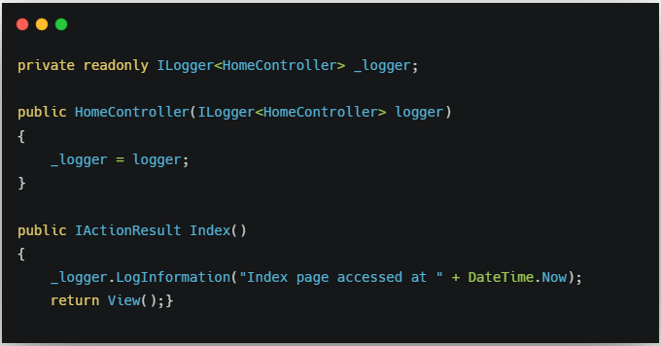

**Serilog**

Is a popular framework for logging

It is popular, flexible, 3rd party

**Implement**

For log information